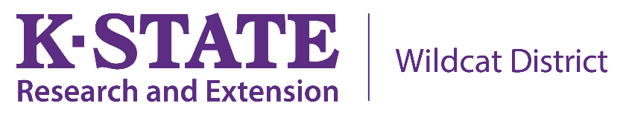

FOR IMMEDIATE RELEASE

For more information,
contact: Tara Solomon-Smith
Adult Development and Aging Agent, Wildcat Extension District
tsolomon@ksu.edu, 620-724-8233

Caregiving and the Holiday Season
As the U.S. population ages, more older adults are likely to be diagnosed with a cognitive impairment. Holidays are stressful for everyone and spending holiday time with someone who experiences memory issues may pose concerns. Here are some tips from the Alzheimer’s Association to help families navigate caregiving circumstances this holiday season.
- Start by creating a safe environment in the home, which could include keeping decorations simple and perhaps even artificial. Walk through the home, making sure to keep all walkways and hallways free of tripping hazards. Ask children in the home to keep toys in designated play areas so that gathering areas stay clean and organized.

- When visiting with someone who is living with dementia, be sure to address the person by name and identify who you are by name. Be patient and supportive if you are not recognized or acknowledged. When communicating, be sure to maintain eye contact and limit other distractions. Having photographs or scrapbooks available during the holiday celebration may be a helpful way to engage in family conversations.

- Playing familiar music and scheduling rest time can provide the entire family with a needed break during the celebration season. Some families plan smaller gatherings, with fewer people and shorter duration. This can help family members manage expectations and not feel overwhelmed during the holidays.
K-State Research and Extension will be hosting a train the trainer opportunity for the Powerful Tools for Caregivers program in February 2020 for individuals who would be interested in helping their community. This national program promotes self-care behaviors, emotion management, self-confidence, and utilizing community resources.
For more information, please contact Tara Solomon-Smith, tsolomon@ksu.edu, or by calling 620-724-8233.

# # #

K - State Research and Extension is an equal opportunity provider and employer

